Operator’s Manual

EASY WINCH



Manufactured for:

Material handling applications
Rescue fall protection
Confined space entry
Work positioning
Retrieval

Contents

1.INTRODUCTION TO WINCH APPLICATIONS
2. APPLICATION RESTRICTIONS
3. GENERAL SYSTEM REQUIREMENTS
4. WINCH INSTALLATION AND OPERATION
5. CLEANING AND LUBRICATION
6. SERVICING THE WINCH
7. LABELS
8. INSPECTION
9. MAINTENANCE AND STORAGE
10. SPECIFICATIONS
11. WARNINGS AND INFORMATIONS
12. INSPECTION LOG
13. DECLARATION OF CONFORMITY
14. ES DECLARATION

1. INTRODUCTION to WINCH APPLICATIONS

Congratulations on your purchase of an Easy Winch as part of your safety at heights equipment.

Easy winches combine many advanced safety features, including multiple brake pawls, a secondary inertia actuated brake, easy to read visual brake wear indicator, visual overload indicator integrated to the snap hook.

Some versions of these winches feature a unique drive input hub design which allows the winch to be easily switched from a manual crank to various power drive options to allow the winch to be driven with different types of corded and cordless power hand drills.

The winch comes with 5 mm galvanized or stainless steel cable.

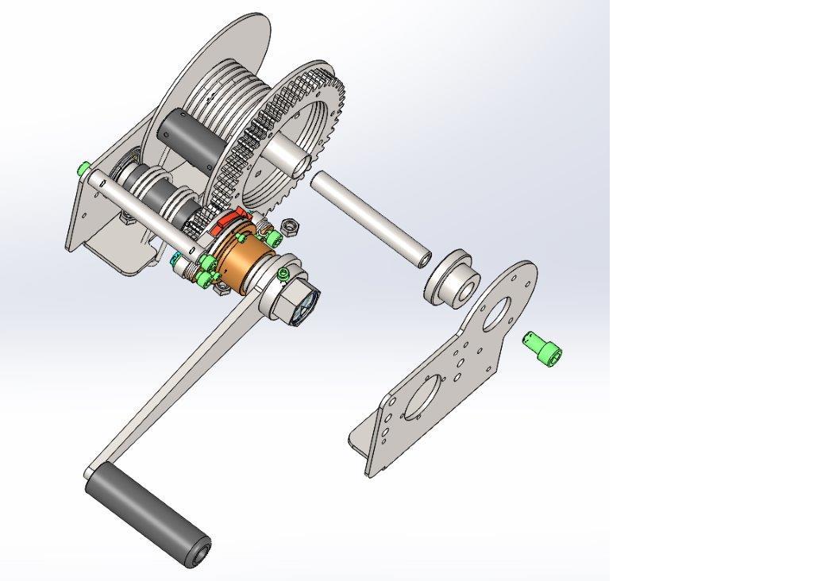
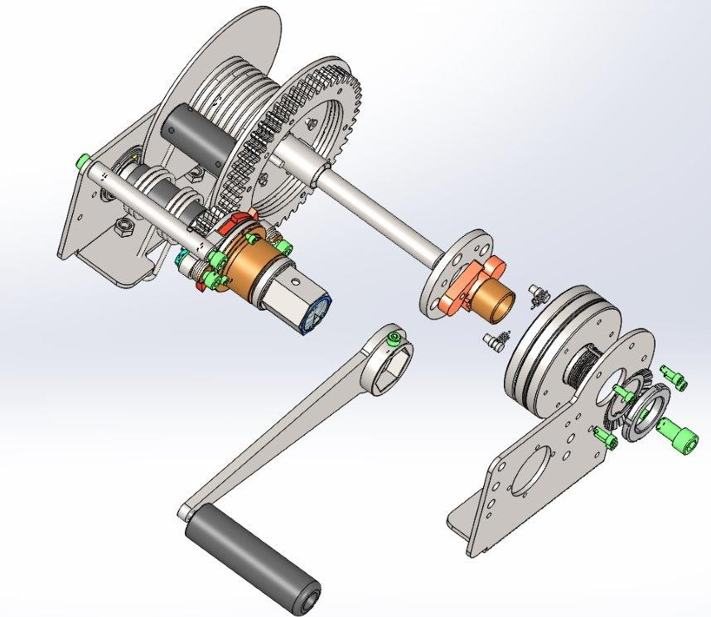

MAN-RATED MATERIAL HANDLING
ADVANCED WINCH BASIC WINCH
May be used for work positioning and material May be used only for material handling.
handling.

Variants of winches:

1) EWB1/Z – Easy Winch Basic 1/Zinc
2) EWB1/SS - Easy Winch Basic 1/SS
3) EWA1/Z – Easy Winch Advanced 1/Zinc
4) EWA1/SS - Easy Winch Advanced 1/SS
5) EWB1/SS/EX - Easy Winch Basic 1/SS - ATEX certificated winch version is in accordance with EN 10204/2005 with elox finishing and grounding cable.
6) EWA1/SS/EX - Easy Winch Advanced 1/SS ATEX certificated winch version is in accordance with EN 10204/2005 with elox finishing construction and grounding cable.

ATEX certificated winch versions
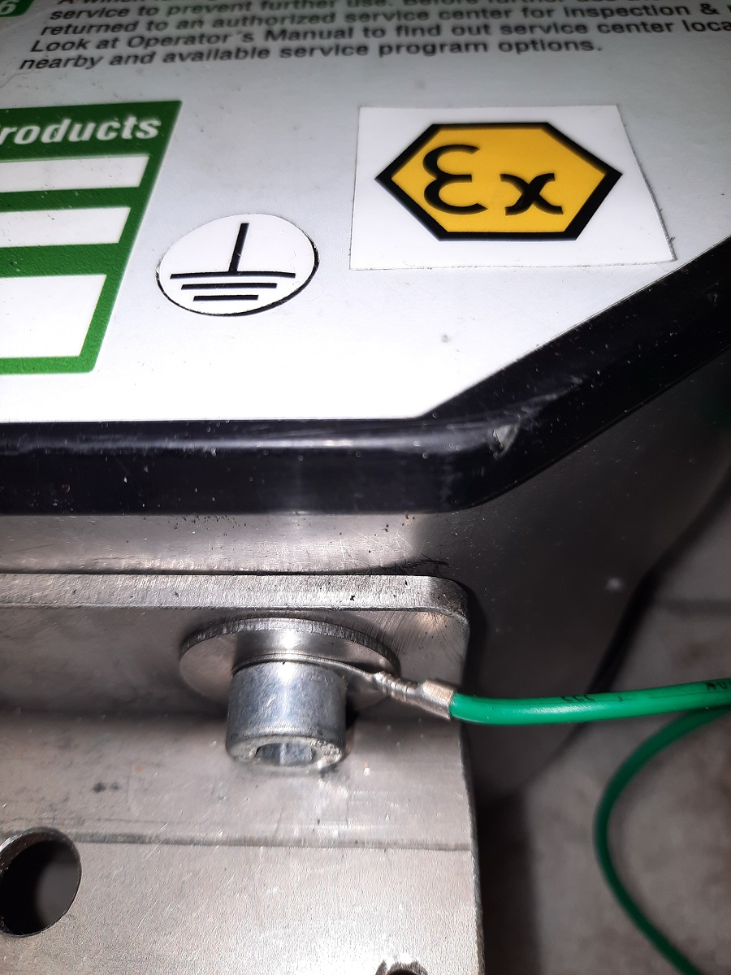

WORK POSITIONING

The winch may be used for the suspension of a worker at a work position for the performance of a task. When a worker is suspended in a work seat or harness, a secondary personal fall arrest system must be used in addition to the suspension line. Advanced winch comes with secondary brake system which is identical with brake system in Self Retracting Line. (SRL)

CONFINED SPACE ENTRY / RETRIEVAL and RESCUE

Both types of our winches may be used as part of a system to allow for the post-fall rescue of a worker protected by a personal fall arrest system.
The winch may be used as part of a system to facilitate access to and egress from a confined space as well as non-entry rescue in the event of an emergency. This winch meets the requirements of EU standards EN 1496:2017 type B, EN 614-1+A1:2009 art. 1, EN 13157+A1:2010, EN795:2012 type B, EN ISO 12100:2011.

MATERIAL HANDLING

The winch may be used for the raising and lowering of tools, equipment, and other material not exceeding the rated Working Load Limit of the winch. Various jurisdictions may not allow the use of the same equipment to move personnel and material. Be aware of and follow the regulations governing your workplace.

2. APLICATION RESTRICTIONS

There are restrictions and limitations that must be carefully considered in the selection, installation, and operation of this winch. Serious injury or death may result from failure to consider these factors.

SITE CHARACTERISTICS, PHYSICAL and ENVIRONMENTAL FACTORS

Work sites have associated with them any of several hazards related to the site itself. These may include but are not limited to poisonous or explosive atmospheric conditions, poisonous or corrosive chemical hazards, hot surfaces, electrical hazards, sharp edges, engulfment hazards, or moving machinery.

WORKING LOAD LIMIT

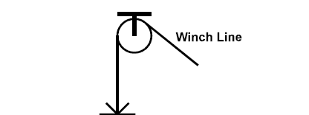
This winch is designed and rated to a working load limit of 1 person weighting a maximum of (including all clothing, tools, and equipment) 145 kg.
MAXIMUM LOAD = 145 KG

3. GENERAL SYSTEM REQUIREMENTS

TRAINING

Prior to working with this winch all users must receive training from their employer on all equipment involved, as well as appropriate training in Fall Protection, Confined Space, Rescue, Material Handling, General Safety.
Users must fully read, understand and follow this manual and any other instruction manual(s) related to the system being used, or have the instructions explained to them, before using this unit.

ANCHORAGE STRENGTH

Winches may only be used with anchor points that comply with EU standards.
MUST BE designed, installed, and used under the supervision of a Qualified Person.
The standards covering different situations specify various anchorage requirements. However, at no time can the anchorage provide any less than the greater of:
Safety factor on the maximum arrest force (MAF) rating has to be in compliance with EU standards (6 KN).
All installations MUST BE used under the supervision of a Qualified Person.

COMPATABILITY OF CONNECTORS

Connectors used to connect components in the system must be compatible with each other to ensure sufficient strength and eliminate the risk of accidental disengagement or rollout during use. Connectors supplied with products designed, manufactured have to be in compliance with EU standards.

FALL PROTECTION

Activities involving working at heights require the use of equipment to protect the worker in the event of a fall. Suitable fall protection must be provided as required by applicable local regulations when using this winch.

CONFINED SPACE SAFETY

When this winch is used as part of a system involving work in a confined space, IS BEING RECOMMENDED always follow an approved confined space safety plan meeting all local regulations

SWING ANGLE

Take care to minimize the potential for swing fall when working at heights. At no time should the angle of the winch line exceed 5 degrees with respect to the vertical

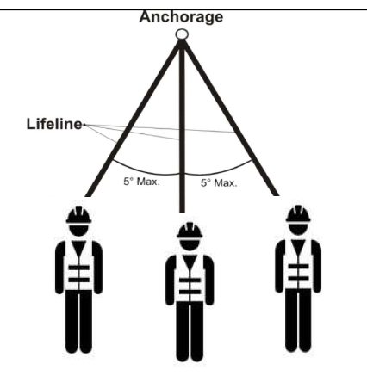

4. WINCH INSTALLATION and OPERATION

This winch is designed for use in conjunction with various styles of support structures to meet different requirements. Supporting structures have to be in compliance with EU standards and manufacturer’s requirements.
Other applications must be designed, installed, and used under the supervision of a Qualified Person. All installations must be approved by a Qualified Person.

WINCH INSTALLATION

For the installation of the winch must be used a suitable bracket which is in accordance with the requirements of manufacturer and EU standards.

WINCH OPERATION

Once the winch has been properly installed into the system, the operation of the winch is as explained below. No person shall use this winch without proper training. Any user must fully read and understand this manual and any other instruction manual(s) related to the system being used, or have the instructions explained to them, before using this equipment.

ATTACHING A WORKER TO THE WINCH LINE

Any worker who is connected to this winch MUST wear a full body harness designed, tested, and approved for fall arrest. The winch line MUST be connected to the REAR OR FRONT D-Ring on the harness.
Extend sufficient winch line to allow the line to be easily attached to the worker’s D-Ring. Be sure to maintain sufficient tension FOR PREVENT OF LINES TWISTING.
Attach the winch line to the worker’s D-Ring, making sure that the snap hook operates smoothly and fully locks when attached.
Retract the winch line until the line is snug, and have the worker slowly lift their feet off the ground to verify system integrity.

RAISING OR LOWERING A WORKER

A worker attached to the winch line is lowered by cranking the winch handle counterclockwise and raised by cranking the winch handle clockwise. DO NOT use the winch if the rotation of the winch handle is reversed, or if the winch does not make a regular clicking sound when cranking the winch handle in a clockwise direction.
Wear gloves if your hands will come in contact with the winch line.
Maintain sufficient tension on the winch line, either from the weight of the worker or manually, to ensure that the line winds evenly onto the spool. Do not allow any slack line to accumulate between the winch and the worker if there is any risk of a fall occurring. Serious injury or death may result if a worker falls while connected to a slack winch line.

DRILL MACHINE + ACCESORY
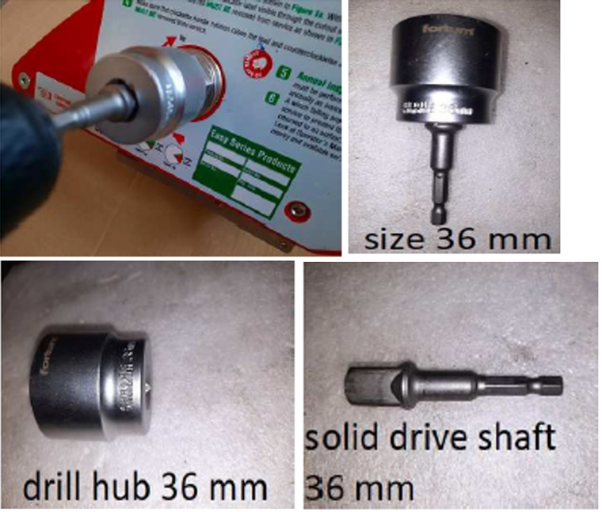
Depending on the type of the application, the regulations governing the use of powered winches to raise and lower workers in various jurisdictions, and the type and specifications of power drills available, there are several configurations of Power Drive accessories that may be appropriate.
Picture shows the simplest option of directly driving the input hub using a solid drive shaft and a low speed high torque drill. Drill requirements: min. 55 N-m; 200 RPM!!!
These direct drive configurations are suitable for personnel and material handling applications.

5. CLEANING AND LUBRICATION

CLEANING THE WINCH

Use a solution of warm water and a mild detergent to clean the exterior surfaces of the winch and the winch labels. Do not soak or submerge the winch, as internal corrosion or other damage may result. Do not use solvents or other cleaners to clean a wire rope, as this may remove internal lubrication.
Basic cleaning should be performed at least annually as part of the annual inspection or more frequently as required when used is under harsh conditions.

LUBRICATION

If required, clean and lubricate the winch and all its parts as explained in the picture 4 below. Do not use solvents or other chemicals to clean the winch.Lubrication of the wire rope (if so equipped), snap hook, crank handle knob, and brake pads should be performed at least annually as part of the annual inspection, or more frequently as required to maintain winch performance under harsh conditions.

BRAKE PAD LUBRICATION

To lubricate the brake pads in the winch, hold the spool from turning and rotate the crank handle counterclockwise at least 10 revolutions to completely disengage the brake mechanism. While continuing to rotate the crank handle counterclockwise, spray WD-40 or other lubricant as approved by manufacturer around where the crank handle hub enters the winch housing.

SNAP HOOK LUBRICATION

After cleaning and inspection as instructed, lubricate the locking mechanism and swivel with light oil and wipe away any excess with a clean cloth.

CRANK HANDLE KNOB LUBRICATION

Lubricate the crank handle knob with light oil as required and wipe away any excess with a clean cloth.

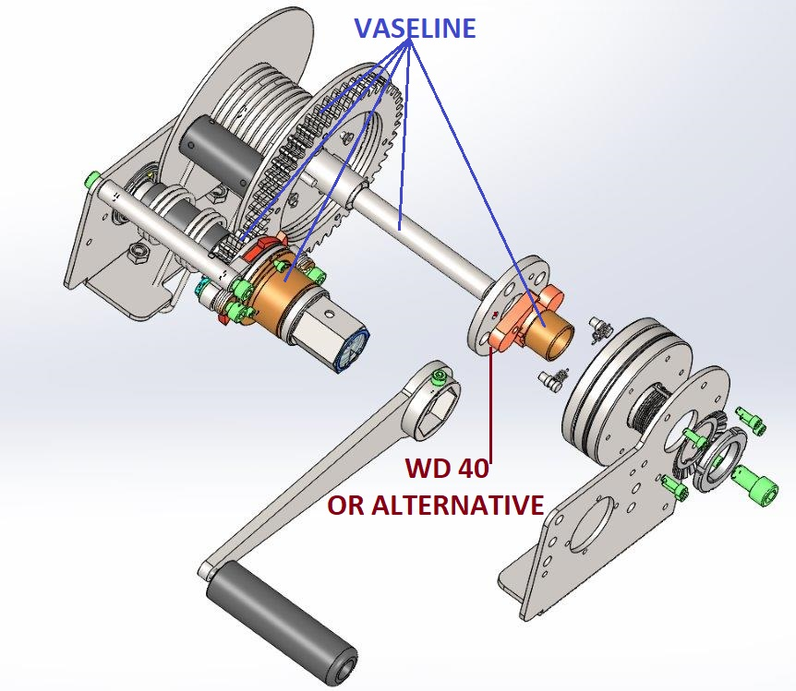

6. WINCH SERVICE

ROPE REPLACEMENT

WARNING!

Always keep minimum cable length on the drum (1,8 m). On the drum follow the red sign on the cable which indicates it.

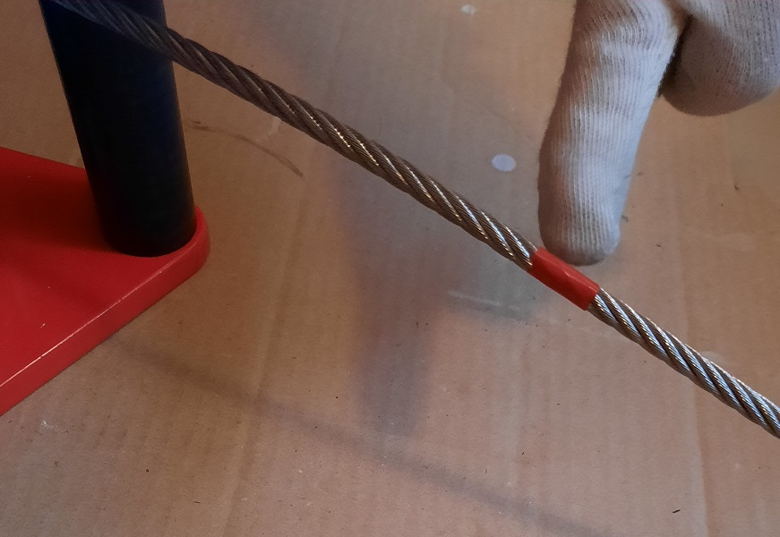

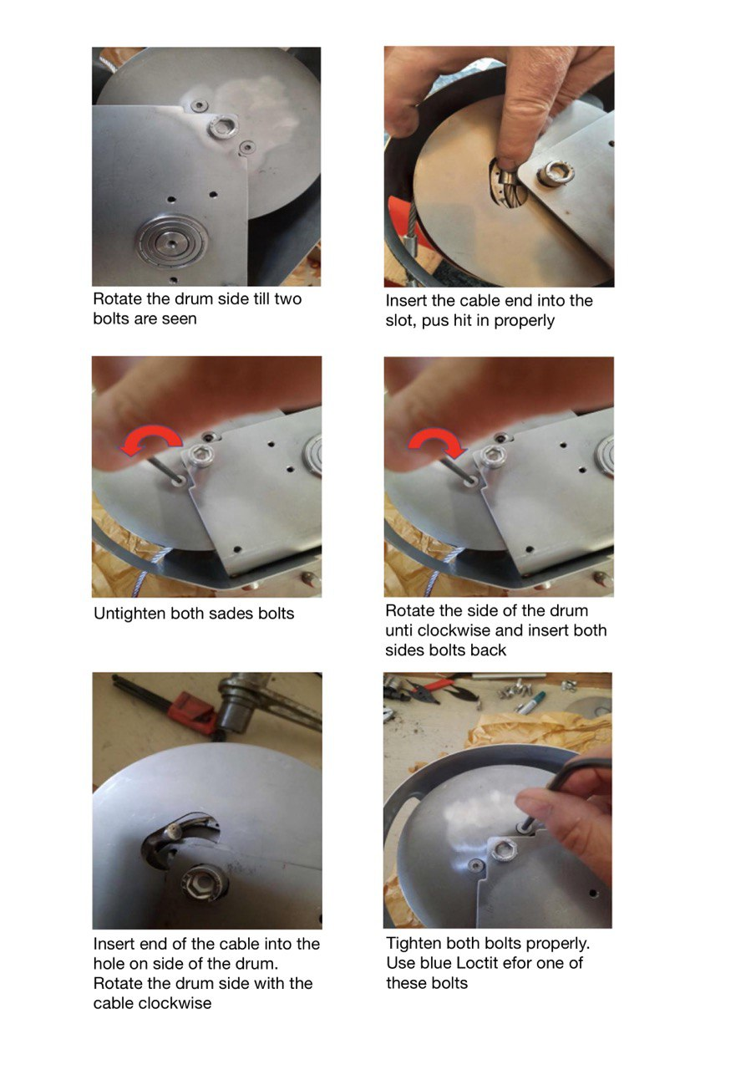
Rope replacemen

WINCH BRACKET INSTALLATION – RECOMMENDATION

Regular winch
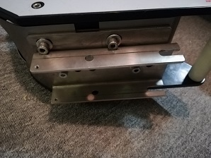
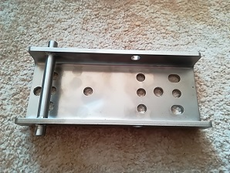

UB bracket supposed to be installed Winch plus UBCP - standart winch package delivery
on anchoring construction using 2 bolts
M10.
Anchoring constriction might be tripod,
david system etc.

ATEX certified winch
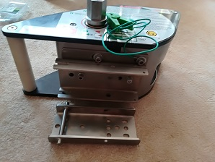
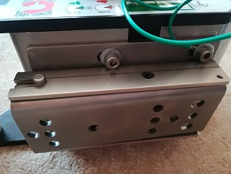

ATEX certified winch - ATEX certified winch with permanently install bracket complete bracket package UBCP plus UB bracket (not part of winch package)

7. LABELS

Below are pictures of the stickers that belong to the winch.
Check the legibility of the stickers before each use of the winch, damaged stickers must be replaced.
Contact your distributor or manufacturer for replacement labels.

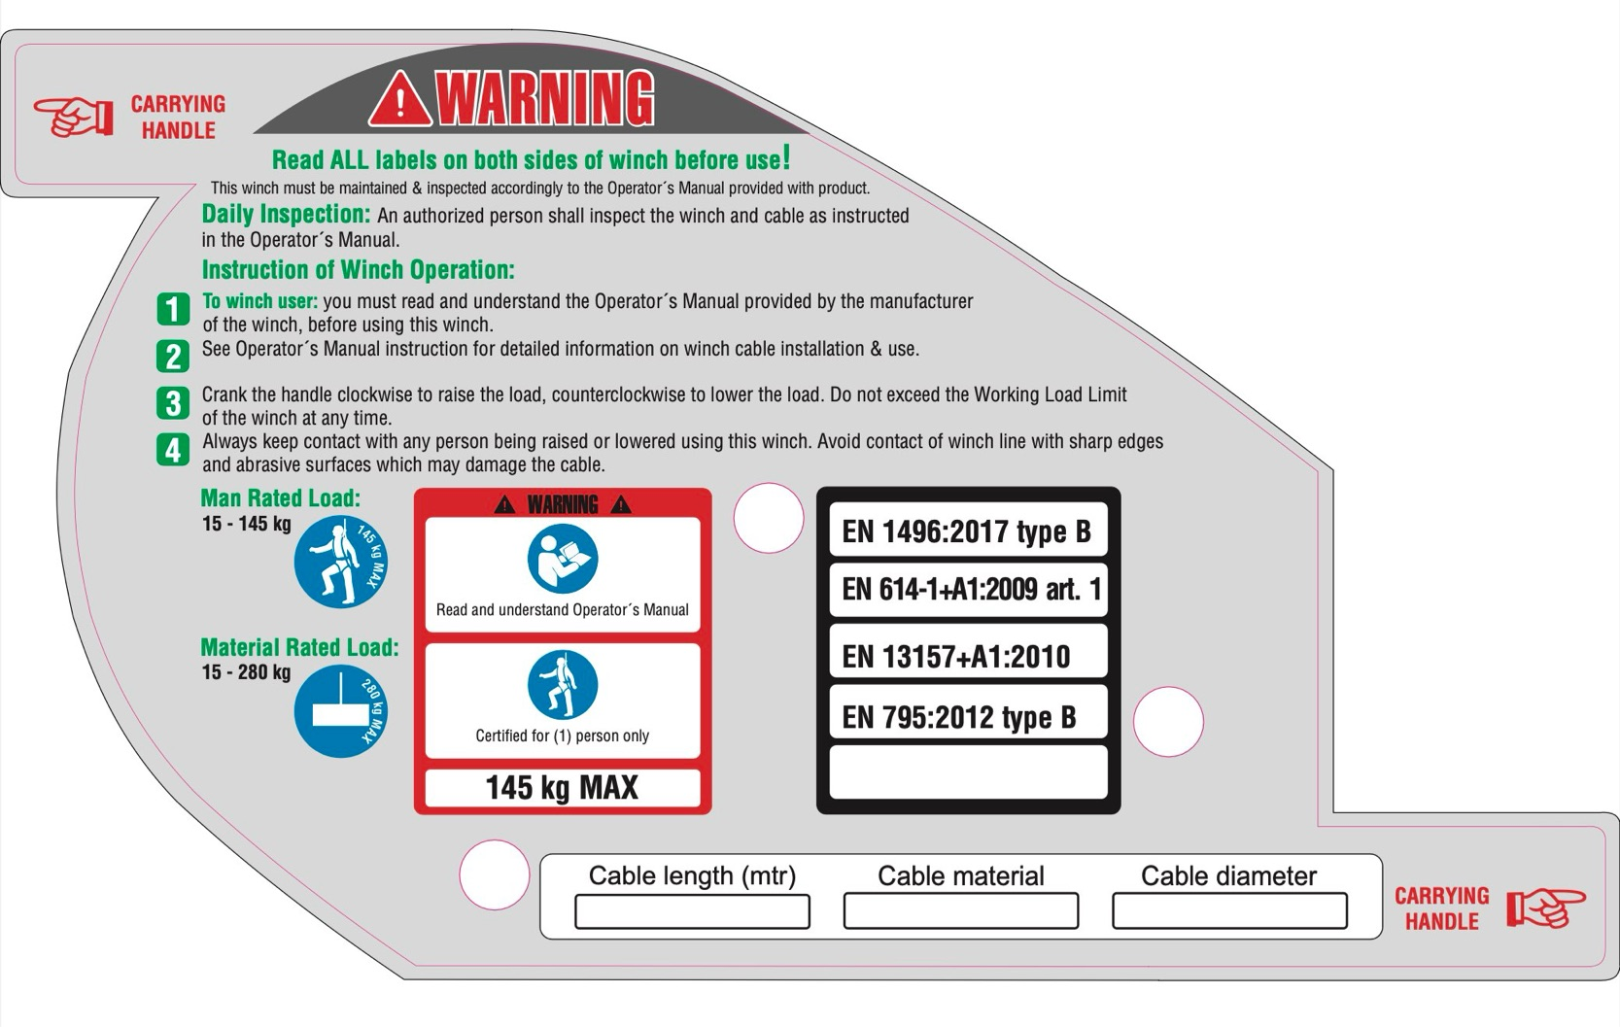

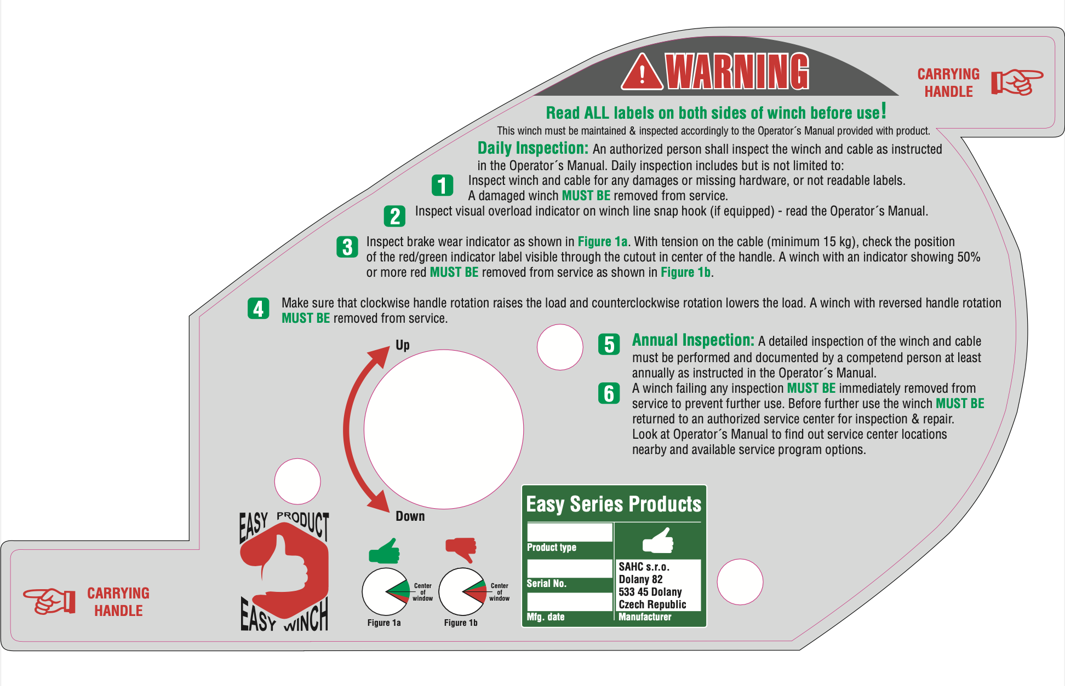

8.INSPECTION

This winch must be inspected before each use as explained. Daily inspection instructions are also explained on the labels on the winch (section 7. LABELS). Winch must be inspected once a year and in the case of the fall.
Any problems must be reported immediately to your supervisor, and the equipment labeled to prevent further use until it has been repaired.

DAILY INSPECTION

The winch must be inspected before each use. Report any problems or concerns to your supervisor, and do not use the equipment until they have approved doing that.
Inspect the winch, winch line, snap hook, and mounting brackets for physical damage; bent parts, cracked housings, dented covers, lose or missing hardware or parts, missing, or illegible labels. Replacement labels are available from your dealer by ordering the part number shown on each label.
While minor cosmetic damage will not effect the function of the winch, a seriously damaged winch MUST BE removed from service and returned to an authorized service center for repair prior to further use.

ANNUAL INSPECTION

At least annually, and more frequently if subjected to harsh conditions or excessive use, this winch MUST BE given a detailed inspection by a competent person as described below, and the results recorded in an Inspection Log. A sample Inspection Log is provided in section 11; Inspection Log - please make photocopies of this sample to record all inspection results.
NOTE: Any time a winch is returned to a factory authorized service center for repair, please provide photocopies of all previous Inspection Log sheets for that winch to assist with diagnosis and processing of any warranty claims.

INSPECTION PROCEDURE

Inspect the winch for physical damage, brake wear indicator reading, and crank handle rotation direction. Record the results in the Inspection Log.
Inspect the condition of the winch line snap hook and record the results on the Winch Inspection Log sheet.

IMPORTANT: Be sure to review any previous inspection records to be aware of existing winch line concerns and to allow for re-inspection of any potential problem areas. Cumulative findings may lead to the need for winch line replacement when looked at together.

SNAP HOOK INSPECTION

Overload Indicator Activation
Inspect the visual Overload Indicator on the snap hook to ensure that the winch has not been overloaded. If a red band is visible as shown , the winch has been overloaded. A winch which has been overloaded MUST BE removed from service and returned to an authorized service center for repair prior to further use.
A winch which has been overloaded MUST BE removed from service and returned to a factory authorized service center for repair.

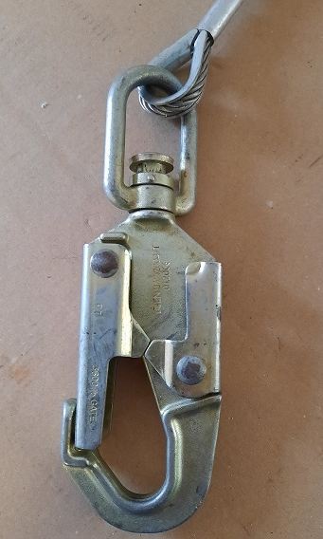

Inspect the condition of the snap hook for any mechanical damage, bent, missing, or corroded parts. Any winch with a damaged snap hook MUST BE removed from service and sent to a factory authorized service center for repair.
Check the function of the locking mechanism for free operation, and make sure that the gate cannot be opened without first depressing the keeper. Lubricate the mechanism with light oil. If the locking mechanism does not operate freely after lubrication, the winch MUST BE removed from service and sent to a factory authorized service center for repair. Ensure that the swivel rotates freely and lubricate with light oil. If the swivel does not operate freely after lubrication, the winch MUST BE removed from service and sent to a factory authorized service center for repair.
Inspect the thimble, ferrules, and winch line forming the eye holding the snap hook for any wear, cuts, fraying, broken wires, or other damage. If there is any damage to the connecting hardware, or there is any winch line damage adjacent to the eye, the winch MUST BE removed from service and sent to a factory authorized service center for repair.

WIRE ROPE WINCH LINE INSPECTION

If the winch you are inspecting is equipped with a wire rope winch line, inspect the wire rope as follows and document the findings in the Rope Inspection Log.

INTRODUCTION TO WIRE ROPE TERMINOLOGY

Before discussing wire rope inspection criteria, you need to understand the basic construction of wire rope and the terms used to describe. Wires (a) are the individual elements that make up a wire rope. A number of wires are laid together to form strands (b), and then a number of strands are laid together around the core (c) to form the wire rope (d).

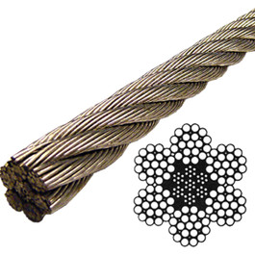

The lay length is defined as the distance along the wire rope that it takes a strand to completely move around the core.
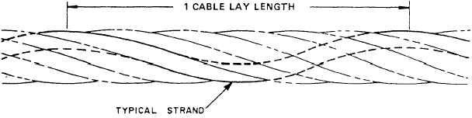

These terms are used to define the criteria for accepting or rejecting a wire rope winch line for continued service.

WIRE ROPE INSPECTION PROCEDURE

Have a helper slowly crank the winch to pay out the entire length of the wire rope while maintaining approximately 10 kg tension on the line. Use a stiff wire brush to clean any built up lubricant and other contaminants from the cable as you are winding it off the drum. Carefully inspect the attachment point of the wire rope to the winch drum for any wear, fraying, loose fittings, or other damage.

Wear heavy gloves to prevent injury from any loose or broken wires and inspect the wire rope along its entire length by running it through your hands while visually checking its condition.

BRAKE WEAR INDICATOR READING

Inspect the brake wear indicator. With a minimum (10kg) tension on the cable, check the position of the red/green indicator label visible through the cutout in the center of the handle. A winch with an indicator showing 50% or more red MUST BE removed from service and returned to an authorized service center for repair prior to further use.



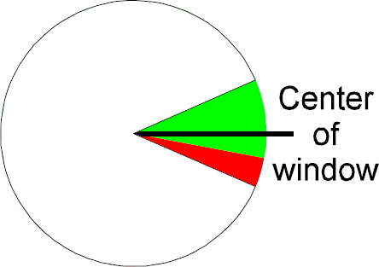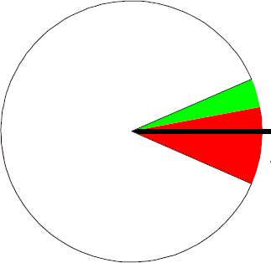

CRANK HANDLE ROTATION DIRECTION AND RATCHET OPERATION

Check the direction of crank handle rotation to verify that the winch line is extended by cranking the winch handle counterclockwise and retracted by cranking the winch handle clockwise. If the rotation of the winch handle is reversed, or the winch does not make a regular clicking sound when cranking the winch handle in a clockwise direction, it MUST BE removed from service and returned to an authorized service center for repair prior to further use.

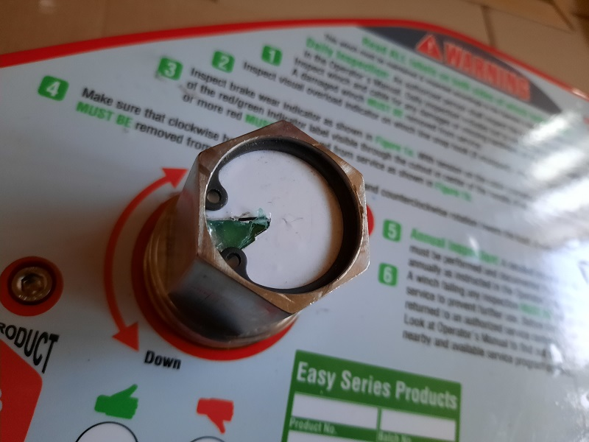

A wire rope with flattened sections where the diameter across the damaged section is less than five sixths of the original diameter MUST BE removed from service and sent to a factory authorized service center for repair.

Also look for:
-Excessive contamination which can prevent lubrication from penetrating the wire rope, increasing internal friction and corrosion
A wire rope winch line exhibiting any damages MUST BE removed from service and sent to a factory authorized service center for repair.
The presence of one or more broken wires in one rope lay length or one or more broken wires near an attached fitting is cause for replacement.

If a broken wire is the result of corrosion or if the wire rope is excessively corroded, the cable must be replaced. Corrosion often develops from the inside out and may have seriously weakened the wire rope by the time it becomes visible.
Location of all broken wires MUST BE recorded in the Winch Line Inspection Log for reference during future inspections.
The protruding end of any broken wires should be removed as they occur by bending backwards and forwards using a pair of pliers until they break deep in the valley between two outer strands. Wear gloves and protective eyewear during this operation.

Before re-installing the wire rope on the drum, inspect the surface of the drum spool, grooves and side plates for any nicks, gouges, or other wear that could damage the wire rope.

When winding the wire rope back onto the drum, ensure that you rotate the winch crank handle clockwise to retract the line, and that the ratchet mechanism produces a regular clicking sound while cranking.

Lubricate the cable with light oil and use a clean cloth to wipe off the excess as you wind it onto the drum.
Record findings of any of the above conditions on the Winch Line Inspection Log sheet, remove the winch from service and make arrangements to have it sent to a factory authorized service center for repair.

9. MAINTENANCE, STORAGE

This winch has been designed to provide many years of trouble free service and requires little in the way of routine maintenance.
Any loose fasteners should be tightened, with the winch being sent to a factory authorized service center for repair if necessary.

STORAGE

Store this winch and other related safety equipment out of direct sunlight in a cool, dry area away from dust, chemicals, or other harmful material. Always inspect before using equipment that has been stored for any extended period of time.

10. SPECIFICATIONS

This winch is constructed primarily of zinc-plated steel, STAINLESS STEEL AND ALUMINIUM.
This winch may be equipped with various sizes and types of winch lines, including:
Wire ropes (5mm) in either galvanized steel or stainless steel.
Please check the Winch Line Details label for detailed information for the winch line supplied with your winch.
The standard winch weighs 16 kg without cable or mounting brackets. Working length of rope is 18 m,
total length is 20 m.

11. WARNINGS AND INFORMATIONS

1) This device can be used for mandated operation only. Not for material handling operations!!
2) Any modification on device can´t be done without written manufacturer approval.
3) Device can be used only for fall arrest purposes accordingly of operation manual.
4) To complete fall arrest device you must reads and understand this operation manual.
5) Device must be taken out of service if:
a) appears in any doubt about its condition for safe use
b) was used to arrest a fall
and not used again until written confirmation of qualified individuals that can be used again
6) Mounting surface must be capable of supporting a minimum of vertical load 1633 Kg.
7) Device is intended for use in a fall arrest system essentially for the security of the position of the anchor device or anchor point and the way the work, were both possible free fall and may fall distance kept to the minimum. If it is inevitable that the anchor device / point located above the user's position, it shall notify the manufacturer
8) It is necessary that the only acceptable body holding the establishment of a retaining harness that It can be used in a fall arrest system.
9) Life limit of the device is defined only by annual inspections result.
10) Operation manual shall be provided in specific language in each country where device is beeing sold.
11) Product has been tested by SZÚ - Strojírenský zkušební ústav, s.p.Tovární 5, Jablonec nad Nisou 466 21.The Czech republic.
12) EU examination of type Modul B: NB 1015 Strojírenský zkušební ústav, s.p. Tovární 5, Jablonec nad Nisou 466 21 www.szutest.cz
13) Conformity with the type Modul C2: NB 1015 Strojírenský zkušební ústav, s.p. Tovární 5, Jablonec nad Nisou 466 21 www.szutest.cz
12. INSPECTION LOG – see page below

13. DECLARATION OF CONFORMITY – see page below

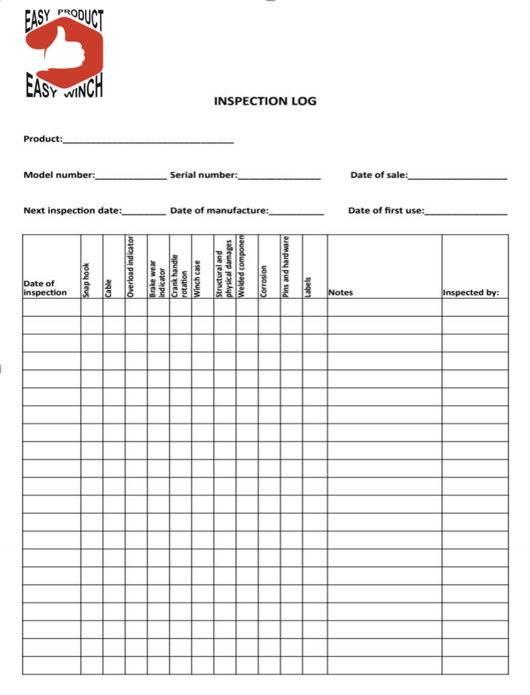
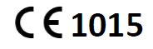
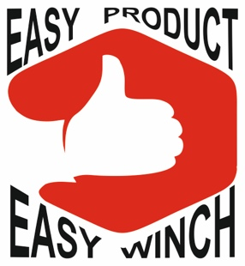

DECLARATION OF CONFORMITY

The manufacturer:

SAHC s.r.o.
Dolany 82
533 45 Dolany
The Czech Republic

declares, that the products below designated:

1) EWB 1/Z – Easy Winch Basic 1/Zinc
2) EWB 1/SS - Easy Winch Basic 1/SS
3) EWA 1/Z – Easy Winch Advanced 1/Zinc
4) EWA 1/SS - Easy Winch Advanced 1/SS
5) EWB/1 SS – EX - Easy Winch Basic 1/SS - Atex certificated
6) EWA/1/SS -EX - Easy Winch Advanced 1/SS - Atex certificated

are in compliance with the Regulation EU n. 2016/425 and are in compliance with the requirements of the harmonized standard Type B EN 795:2012.

Issued by:

Strojírenský zkušební ústav, s.p.
Tovární 89
466 01 Jablonec nad Nisou
The Czech Republic
Notified Body Number: 1015

The PPE is subject to the conformity assessment procedure conformity to type based on internal production controlplus supervised product checks at random intervals (Module C2) under surveillance of the notified body Strojírenský zkušební ústav, s. p., Tovární 89, 466 01 Jablonec nad Nisou, Notified Body Number:1015

Date of issue:
Name: Radovan Pešák
Position: managing director of company SAHC s.r.o.
